Unitree G1 EDU – Product Development Documentation
Table of contents
1 Document purpose 5
1.1 Background and Current status 5
1.1.1 How We Started 5
1.1.2 Current status 5
1.1.3 Provider Dependencies 6
1.2 Future steps 6
2 Basic versioning and info 6
2.0 Huamnoid serial number 6
2.1 Humanoid PC1 versions: 7
2.2 Humanoid PC2 versions: 7
3 Hardware Setup (Robot-provided) and Quickstart 8
3.0 G1 Unboxing 8
3.1 Stand Assembly 8
3.2 Power and Charging 9
1. Battery-powered runtime 9
4 Operation Guidance 10
4.1 Mode explanation: 10
4.2 Remote Control Operation 11
4.2.1 Lying Position Startup 11
4.2.8 Dance Mode 12
5 Network Connectivity 14
5.1 Mobile Connection 14
5.1.1 AP Mode connection 14
5.1.2 STA Mode connection 14
5.2 Development connection to PC2 (recommended) 15
5.2.1 Ethernet connection Dev PC ßà PC2 setup 15
5.2.2 SSH connection 16
5.3 Connecting PC2 to Wi-Fi AP 16
5.3.1 Configuring Wi-Fi using `wpa_cli` (recommended) 16
5.3.2 Configuring Wi-Fi using `nmcli` 17
5.4 Reserved addresses in the G1 network 17
5.5 Network Limitations and capabilities 18
6 Development 18
6.2 Development rules 18
7 Hardware Guide & Development 18
7.0 Available Hardware 18
7.1 Physical Interfaces 19
7.2 GPIO ports 20
7.3 Hardware usage 21
7.3.1 Built-in Audio 21
7.3.2 Built-in Cameras 22
7.3.3 Robot Hands RH56-DFTP 24
7.3.4 External devices 24
8 Agent-Livekit Service Architecture 25
8.1 Supervisor 26
8.1.1 Running the Supervisor on boot 26
8.2 LiveKit Server 26
8.3 Voice Agent 26
8.3.1 Configuration 27
8.3.2 Agent construction and behaviour 27
8.3.3 Prewarming speech components 28
8.3.4 Starting the session 28
8.3.5 Room and audio handling 28
8.3.6 Session start and greeting 28
8.3.7 Running as a livekit worker 29
8.4 Audio Bridge 29
8.4.1 Audio Bridge Modes 29
8.5 Camera Bridge 30
8.5.1 Camera Bridge Modes 30
8.6 Gesture Bridge 30

Version | Date | Reviewers
Version 1.0 – Internal Release | (February 2026) | RMŠ,

1 Document purpose
This document serves as the central technical reference for developers working on the Unitree G1 EDU product development. Its primary goal is to capture and standardize everything needed to bring a robot from a fresh state to a fully working development setup, including additional hardware assembly, OS configuration, network connectivity, operational workflows, service-level integration, and mechanical maintenance.
In addition to setup instructions, the document consolidates practical development knowledge gathered during hands-on work (e.g., configuration details, common pitfalls, quirks, and troubleshooting tips). By documenting these lessons learned, it enables faster and more consistent onboarding of additional robots from scratch, while also supporting continued development and iteration based on the current working state.

1.1 Background and Current status

1.1.1 How We Started
The hopefully first of many Unitree G1 EDU arrived on the 24th of December of 2025, along with 1 disassembled Support Stand, the Unitree R3 Remote Controller, 1 battery charger, 1 Unitree G1 battery and 1 wrongly delivered Unitree Go1 battery. The robot also came preinstalled with the dexterous hands Inspire RH56DFTP (left and right), whereas the “basic rubber hands” that come with the Unitree G1 humanoid robot came in the case.
The additional Unitree G1 battery we had ordered came on the 12th of January of 2025, when we returned the incorrectly delivered Go1 battery.

1.1.2 Current status
The Humanoid G1 EDU can run on its PC2 a LiveKit agent pipeline with speech and vision capabilities, along with triggering predefined gestures from the Unitree SDK.

1.1.2.1 Speech
The speech is implemented as a Vitasis STT -> Azure OpenAI LLM -> Vitasis TTS pipeline, where for the input/output we can use the built-in speaker, built-in microphone, externally connected microphone and externally connected speaker (in our testing, we used the Jabra Speak2 55 conference speaker/microphone).

1.1.2.2 Vision
The vision portion is implemented for now as grabbing the images from either an external camera that is connected to the Humanoid G1 or from the built-in RGB camera from the RealSense D435i module. These images are then fed with to the LLM along with the query from STT.

1.1.2.3 Gestures
The gestures are initialized through the gestures-bridge (uses G1ArmActionClient), where we connect via the interface (eth0 and other options) and are then able to be triggered by the LLM. More details for the whole setup can be found in Chapter 6 TODO.

1.1.2.4 XR Teleoperation
In the last few days of completing Phase A, teleoperation had been set up to work. The teleoperation is currently set up to support arm and hand teleoperation only, no full-body yet. For this, full-body tracking in the form of Kinect 2 VR or something similar is needed.
The XR_Teleoperation repo must be modified in order to work – this will be pushed to the repo.

1.1.3 Provider Dependencies
Currently, the agent uses the following providers:
TTS – Vitasis (Soniox also working but not pushed to main)
LLM – Azure OpenAI
STT – Vitasis (due to Slovenian language limitations)

1.2 Future steps
In future we propose the following improvements:
- Agent latency
- “real-time” vision
- Hardware upgrades
- Speaker diarization

2 Basic versioning and info

2.0 Huamnoid serial number
E21D6000PB4C1M8A

2.1 Humanoid PC1 versions:
Hardware version: V1.0
Software version: V1.4.7
Machine Type Current Version: 15
Service Versions:
- ai_sport: 8.5.1.1
- audio_player_service: /
- bashrunner: 1.0.3.1
- basic_service: 1.0.1.37
- battery_guard: 1.0.0.2
- chat_go: 1.9.2.13
- dex3_service_l
- dex3_service_r
- g1_arm_example: 2.0.0.19
- lidar_driver: 1.0.0.5
- log_system: 1.0.0.10
- master_service: 1.2.1.2
- motion_switcher:1.0.01
- net_switcher: 1.0.2.1
- ota_box: / (disabled on STA-L)
- ota_pipe: /
- robot_state: 1.2.3.6
- robot_type_service: 1.0.1.3
- ros_bridge: 1.0.0.4
- state_estimator: 1.0.0.3
- unitree_slam: 1.0.2.1
- video_hub_pc4: 1.0.2.3
- video_hub_pc4_chest: /
- vui_service: 2.1.0.12
- webrtc_bridge: 1.0.8.10
- webrtc_multicast_responder: /
- webrtc_signal_server: /

2.2 Humanoid PC2 versions:
Ubuntu 20.04, global Python 3.8.X

3 Hardware Setup (Robot-provided) and Quickstart

3.0 G1 Unboxing
The robot must first be unboxed from its case. Requires 2 people.
- First pull the legs upwards into a 90-degree bend so that they are pointing towards the sky.
- Unfold the arms in a similar manner so that they also point towards the sky, then one person must lift it by the hands of the humanoid, while the other person lifts it by its legs and place it on the floor.
- The robot should then be put into a sitting position on a chair, where it might need some help to hold it stable.
- Insert the Unitree G1 battery into its side, and turn it on by doing the following button sequence: short press -> long press/hold until the initial fans start up.
- Wait for the humanoid to say “Zero Torque mode”. Enter damp mode by pressing L2+B
- Hold the G1 stabilized by the handle on the top of its back to keep it stable and press L2+UP, helping the robot stand up.
- Press R2+A to enter running mode which enables balanced standing.

3.1 Stand Assembly
Time: ~1 hour. People: 2 recommended.
Step 1: Attach the wheels to the base legs using the appropriate bolts, washers, and nuts. Some wheels are locking and some are non-locking; place the locking wheels where you want to access the brakes easily, and keep the orientation consistent.
Step 2: Attach the metal legs to the back base plate (the plate is made from two metal poles). Insert a cotter pin through each hole on the base back plate and fully seat it so it cannot slip out.
Step 3: Attach the winch arm to the base plate by sliding the arm into the opening at the base of the upright plate. Install the correct bolt with a washer and nut, then tighten it so the arm is secure and aligned.
Step 4: If the winch arm arrives folded, remove both bolts at the bend, rotate the arm upward, and keep it supported so it does not slide out of the base opening. Reinstall the bolts, washers, and nuts exactly as before, but with the arm in the upright position.

Final check: confirm all fasteners are tight, cotter pins are seated, wheels spin freely, and locking casters engage and hold the stand in place.

3.2 Power and Charging
Unitree G1 Edu supports two different power options:

Battery-powered runtime
- Typical runtime: ~ 2 hours.
- Charge time: ~1 hour, slightly more depending on battery state and temperature.
- Charger: use the official Unitree G1 charger only
- Connector: the charger and battery charging port (rear side of the battery) use an XT30 2+2 connector.

- Direct power option
- Direct power is supported through the XT30 port on the robot’s leftmost neck port.
- Use 14 AWG wires for the power lead.
- Power supply requirements: 55V constant voltage, up to 20A maximum sustained power draw.

4 Operation Guidance
Unitree G1 can be operated using either the Remote Controller R3, or the mobile app Unitree Explore.
To use the remote controller, you must first pair it with the G1 robot if that has not been done before. To do this, follow Chapter 5.1.1.

4.1 Mode explanation:
Zero torque mode:
- Initial mode the robot boots into when the startup is complete.
- The joints and motors have no force or torque as the name suggests.
- Entry to this mode is possible only via powering the robot on.
Damping mode (L2 + B):
- The main joints for the arms and legs become firmer, while still “dangling”.
- The robot is in no way able to stand or support itself in this mode.
- Entry is done via pressing (L2 + B) or holding (L2 + B) only as an emergency and should not ever be triggered if the robot is in a standing or run/walk mode.
Locked Standing mode (L2 + Arrow Up):
- The robot’s limbs become extended, it supports its own weight, but DOES NOT balance and WILL FALL if unsupported.
- This is an intermediary mode if the robot were to be powered on on the hanging rack.
- The mode can be forced by holding (L2 + Arrow Up), depending on the previous mode.
Running/walking mode HOLD (R2 + A):
- The robot jerks into a standing state, picking itself up into a standing state VERY quickly, which can prove to be dangerous IF the robot is not yet upright.
- Allows the robot to walk via joystick controls, go into dance mode or perform gestures.
Dance mode HOLD(R1 + B):
- MAKE SURE THERE IS ENOUGH SPACE!
- EMERGENCY STOP is DOUBLE CLICK START
- The robot enters dance mode, waiting for a Dance button combination on the remote to perform a dance.
- Wait out the dance but in case of emergency double click START.
Seated mode HOLD(L2 + Arrow Left):
- Make sure there is a chair behind the robot that is both LOW and does not slip away!
- The robot sits back a little less carefully than one would like, and then puts some weight on his legs.
- To exit, you need to enter Locked Standing, position the robot upright on its feet and enter Running/walking mode.

4.2 Remote Control Operation
4.2.1 Lying Position Startup
• Battery ON (short press, then long press)
• Remote control ON (short press, then long press)
• Wait ~1 minute for Zero Torque Mode
• PRESS (L2 + B) → Damping Mode ⚠️ Dangerous if not on the floor or hung (motors are almost inactive)
• L2 + X → Lie → Stand
(Robot enters Run/Walk mode automatically)
4.2.2 Running / Walking
• Left joystick:
– Up: walk forward
– Down: walk backward (requires small forward nudge first for balance)
– Left/Right: strafe left/right
• Right joystick:
– Look around / rotate robot
4.2.3 Running ↔ Walking Mode
• PRESS (R2 + Arrow Up) → Running mode
• PRESS (R2 + Arrow Down) → Walking mode
4.2.4⚠️ Locked Standing (Very Important) ❌
• Do not do it without supporting the robot!
• HOLD (L2 + Arrow Up)
• Disables stabilization – only limb extension
• Balancing is ONLY active in Run/Walk mode
4.2.5 Seated Mode
• HOLD (L2 + Arrow Left)
• NOT recommended (unstable exit)
• Chair must be low and fixed
• Standing up procedure:
– Hold robot upright
– Activate Locked Standing HOLD (L2 + Arrow Up) – help it upright so that it’s standing (with help)
– Switch back to Run/Walk mode (R2 + A)
4.2.6 Turn-Off Procedure (Robot on Floor)
• HOLD (L2 + A) → Squatting mode
– Can stand again by pressing (L2 + A)
• (L2 + B) → Damping mode
• Manually lay robot down
• Battery OFF (short press, then long press)
4.2.7 Gestures (Run/Walk Mode Only)
To end a gesture, wait until completion.
Handshake | SELECT + A
Wave Hand | SELECT + Y
Reject | SELECT + X
Face Wave | DOUBLE CLICK Y
Right Kiss | DOUBLE CLICK X
Clap | DOUBLE CLICK A
Right Raise | DOUBLE CLICK B
Flex Left | DOUBLE CLICK ARROW LEFT
Flex Right | DOUBLE CLICK ARROW RIGHT
Flex Both | DOUBLE CLICK ARROW UP
4.2.8 Dance Mode
• Must be activated from Run/Walk mode
• HOLD (R1 + B) → Enter Dance Mode
• Select dance move to start
• After completion, robot returns to Run/Walk mode
• Emergency Stop: DOUBLE PRESS START ⚠️

EMERGENCY STOP | DOUBLE CLICK START
Dance 1 | R1 + ARROW UP
Dance 2 | R1 + ARROW LEFT
Dance 3 | R1 + ARROW RIGHT
Twist | R2 + LEFT
Kung Fu | R1 + SELECT
Jeet Kune Do | R2 + ARROW UP
Roll Up | R1 + DOWN

5 Network Connectivity
The G1 robot supports multiple network operation modes. First, we will cover the mobile app connection, then we will focus on connecting the G1’s PC2 for development to a development pc.

5.1 Mobile Connection
Connecting the Unitree G1 Edu to mobile has two modes, AP mode and STA-T mode. AP mode is direct connection to the G1’s hotspot, while STA-T connects the robot to your AP and your mobile app connects to it through Unitree’s TURN server.

5.1.1 AP Mode connection
AP mode lets the user’s mobile device connect to the Humanoid’s Hotspot/AP.
- First, the Unitree Explore app must be downloaded.
- An account must be created. If the G1 is bound to an account, you must either log into that account OR unbind the G1 from that account.
- While the robot is on, press the “Add Robot” button.
- Choose the Robot, select AP Mode and at the step with its AP credentials, input them and continue.
SSID: G1_XXXX ; where the XXXX is the unit number (random)
Password: 88888888 ; by default 88888888 or 00000000*
- The connection might take a while, so be patient and keep the phone next to the humanoid.
- Success!
If this is your first connection, we recommend Pairing the controller to the G1.
- Navigate to Device -> Data -> Remote Control Binding
- Make sure the ID matches the ID printed on the sticker on the back of the remote
*password must be changed to something more secure. For info, follow Chapter X.X
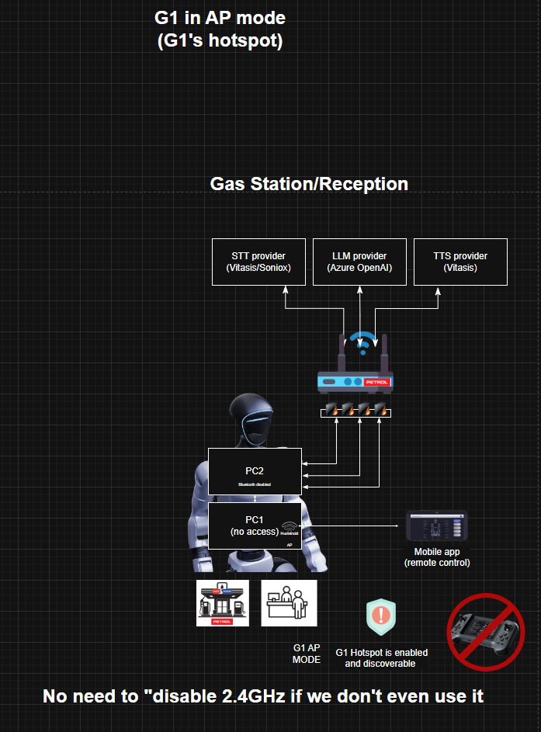

5.1.2 STA Mode connection
STA allows the robot to be controlled remotely from a mobile device through the network. The communication path depends on the setting you choose in the setup. In STA-T it goes from the mobile device to the Unitree’s TURN server and to the Robot, which must have internet connection with the Hotspot it is attached to, or in STA-L it can go locally without Unitree’s TURN server (this must be tested by tracing where packets go, or by disabling internet access for that AP).
- Connect in Unitree Explore mobile app to G1 using AP mode.
- Navigate to Device -> Robot Settings -> Change another connection -> Wi-Fi mode
- Enter the Wi-Fi credentials of the Wi-Fi AP you want to connect to. (optionally choose “Control from a different network” for STA-T mode).
- The connection might take a while, so be patient.
- Success!
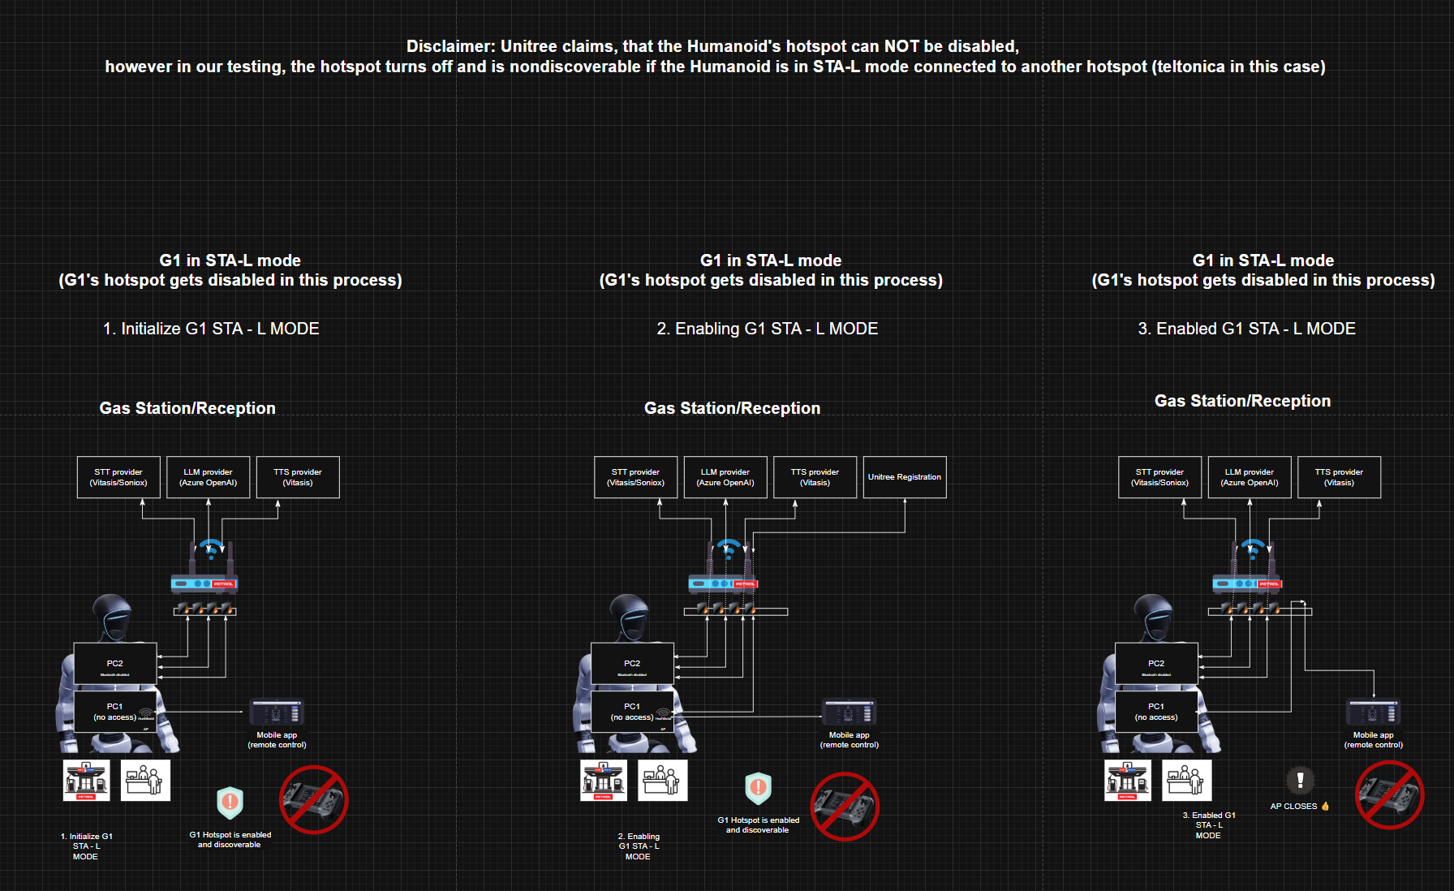

5.2 Development connection to PC2 (recommended)
For development on the Unitree G1 Edu’s PC2 we need to connect to it. This must first be done using a wired connection (Ethernet/UTP) on port 5 and can not be done in any other way for the first time. Alternatively ports 6, 7, 9 can be used for connection, if using an ETH-USBC adapter, but it is not recommended.

5.2.1 Ethernet connection Dev PC ßà PC2 setup
Connecting the G1’s PC2 to a developer’s PC must be done in this way until the PC2 is connected to a Wi-Fi AP. This is different to 4.1.2 as that is connecting the main (PC1) to the AP. The dev PC must be set to a static IP in the 192.168.123.x subnet.
On the dev’s PC:
- Set the Ethernet adapter to static IP, recommended 192.168.123.100.
(any 192.168.123.x works, as long as it does not conflict)
- Subnet mask: 255.255.255.0
- Gateway: leave empty
Physical connection:
- Plug the Ethernet cable into the Ethernet interface of the dev’s PC.
- Plug the other end of the UTP cable into port 5 of the robot.
From here an SSH connection can be made to the PC2, continue to Chapter 4.2.2.

5.2.2 SSH connection
The SSH connection to the PC2 can be made either wired or wirelessly.
- wired connection, the developer PC’s ethernet adapter must have a static IP in the 192.168.123.x subnet.
- ssh unitree@192.168.123.164
- password by default is 123

- wireless connection, the Humanoid’s PC2 must have a connection to the AP the development PC is connected to/be in the same network.
- ssh unitree@IP
- password by default is 123.
To connect the PC2 to an access point, refer to Section 4.3.

5.3 Connecting PC2 to Wi-Fi AP
Wi-Fi connection can be configured using either:
- `wpa_cli` (recommended, but lower level)
- `nmcli` (network manager CLI)

5.3.1 Configuring Wi-Fi using `wpa_cli` (recommended)
- Start `wpa_cli` (default interface is typically wlan0):
wpa_cli

- Add a network:
add_network

- Set SSID:
set_network 1 ssid “wifi name”

- Set password:
set_network 1 psk “wifi password”

- Enable the network:
enable_network 1

- Save the configuration:
save_config

- Confirm running status:
status

- Quit the config:
quit

- You can check the PC2 internet access as well using:
sudo apt update

5.3.2 Configuring Wi-Fi using `nmcli`
- Bring the Wi-Fi interface up:
sudo ifconfig wlan0 up

- Enable Wi-Fi radio
sudo nmcli radio wifi on

- Check Wi-Fi radio state:
nmcli radio wifi

- Connect to your Wi-Fi AP:
nmcli device wifi connect <SSID> password <password>

5.4 Reserved addresses in the G1 network
Address | Function | Notes
192.168.123.164 | PC2 | G1’s internal PC for development. Ubuntu on an ARM processor.
192.168.123.161 | PC1 | Main locomotion PC of the G1, locked to any outside users other than Unitree.
192.168.123.210 | Left RH56 DFTP Hand | Data for the dexterous hand goes through this address.
192.168.123.211 | Right RH56 DFTP Hand | Data for the dexterous hand goes through this address.
192.168.123.120 | Livox Mid-360 LiDAR | Data for the LiDAR sensor

5.5 Network Limitations and capabilities
In this section network functionalities and capabilities are explained in a table below.
CASE | Remote Controller Functionality | Mobile App functionality (AP) | Mobile App functionality  (STA-L) | Mobile App functionality (STA-T)
Disabled BT | ✓ | ✓ | ✓ | ✓
Disabled wlan0 (internet) | ✓ | ✓ | ✓ | ✓
Disabled BT  Disabled wlan0 | ✓ | ✓ | ✓ | ✓

G1 hotspot is always discoverable UNLESS the G1 is in STA-T or STA-L mode and connected to an external AP. Unitree claims that the G1 AP is always on, so we can not say that this is intended behavior or a bug.

5.6 Network Limitations and capabilities
As the Humanoid robot will be connected to Azure services, the ELK stack, Vitasis and other providers, a clear architectural diagram is required for easier use and explanations. Due to the complexity of the architecture, the below image may be unreadable, so it is advised to refer to the DRAWIO document.
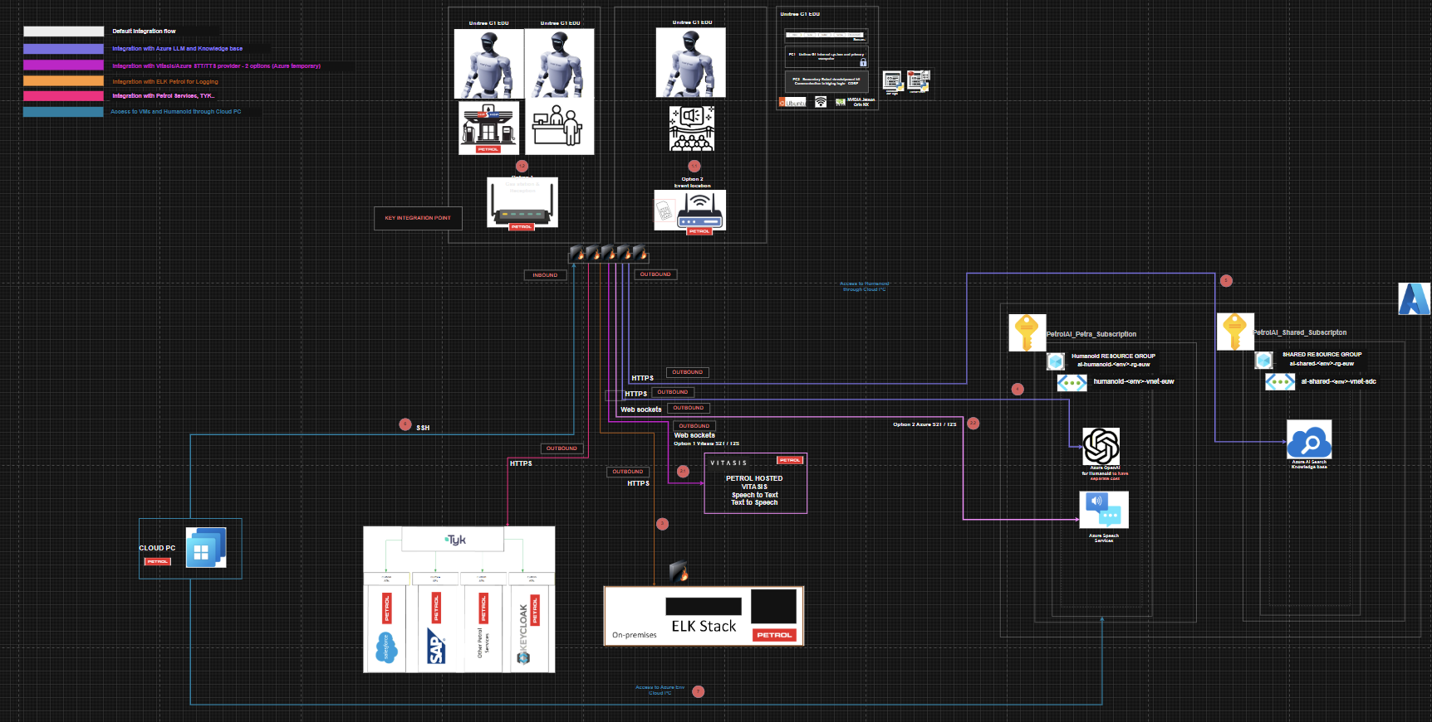

6 Development
Because of the questionable experience with Unitree support so far, and deadlines being short, down-time of the robot cannot be afforded. Destructive or persistent actions across boots are not permitted under these rules.

6.1 Development guide and environment setup
To develop using python on the Unitree G1 EDU, when connected to PC2, first a virtual environment using uv must be set up. This is to ensure that the Python version is correct.
To use the repo, package/dependency installation guide from the repo’s main README must be followed.

6.2 Development rules
The ethernet interface of PC2 must not be touched! In worst case event, if the PC2 is not connected to a Wi-Fi AP, the ethernet interface might be the only point of access to the PC2.

7 Hardware Guide & Development
The section under the G1's head is equipped with physical interfaces which are connected to the PC2 of the G1.

7.0 Available Hardware
Built-in Camera module
Built-in Microphone array
Built-in Speaker
DFTP Hands
Plastic Hands
Ugreen splitter
Lidar
Battery

7.1 Physical Interfaces
The section under the G1's head is equipped with physical interfaces which are connected to the PC2 of the G1.
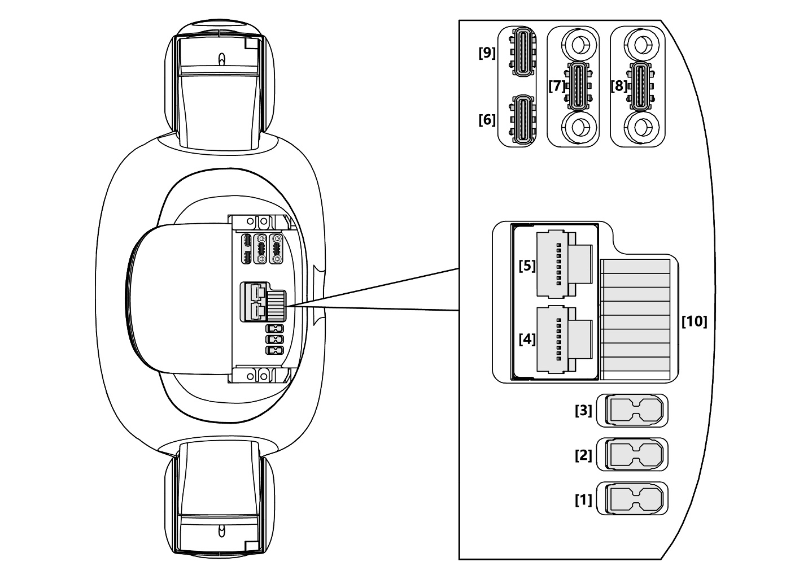

No. | Connector Name | Interface Description for short | Interface specification
1 | XT30UPB-F | VBAT | 58V/5A Battery power output  (directly connected to battery power here)
2 | XT30UPB-F | 24V | 24V/5A power output
3 | XT30UPB-F | 12V | 12V/5A power output
4 | RJ45 | 1000 BASE-T | GbE (gigabit Ethernet)
5 | RJ45 | 1000 BASE-T | GbE (gigabit Ethernet)
6 | Type-C | USB Type-C | Support USB3.0 host, 5V/1.5A power output
7 | Type-C | USB Type-C | Support USB3.0 host, 5V/1.5A power output
8 | Type-C | USB Type-C | Support USB3.0 host, 5V/1.5A power output
9 | Type-C | Alt Mode Type-C | Supports USB3.2 host and DP1.4
10 | 5577 | I/O OUT | 12V: 12V/3A power output  See the following table for GPIO details

*port 8 is non-functional on our unit

7.2 GPIO ports
Below are an image and table explanation of the GPIO interface:
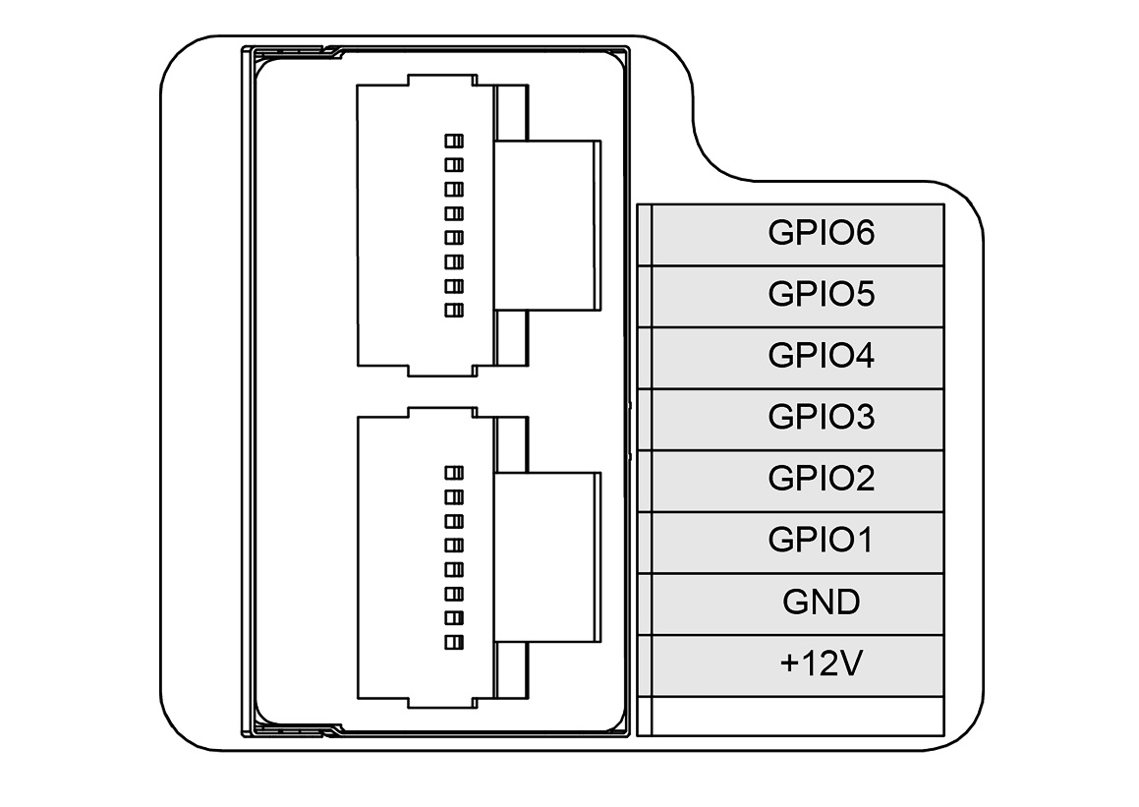
GPIO Number | NX Pin Number | Multiplexing Relationship | Pin name of the debugfs file system
GPIO1 | 203 | UART1_TXD | GPIO3_PR.02
GPIO2 | 205 | UART1_RXD | GPIO3_PR.03
GPIO3 | 232 | I2C2_SCL | GPIO3_PI.03
GPIO4 | 234 | I2C2_SDA | GPIO3_PI.04
GPIO5 | 128 | GPIO | GPIO3_PCC.02
GPIO6 | 130 | GPIO | GPIO3_PCC.03

7.3 Hardware usage
In the subsections below, it is described how to use the built-in hardware appropriately and the external hardware.
Built-in hardware have some specifics of using them, while external hardware such as external cameras should act the same as they do on a regular Ubuntu machine.

7.3.1 Built-in Audio
The G1 exposes the built-in microphone as a UDP multicast stream, and the buit-in speaker is controlled through the Unitree SDK audio client.

7.3.1.1 Built-in Microphone
A UDP socket needs to be created and binded to port 5555, to then join the multicast group with with IP_ADD_MEMBERSHIP using MCAST_GRP and LOCAL_IFACE_IP.
Incoming packets are buffered until a full frame (--mic-frame-ms, default 20ms) is available, then pushed into a bounded queue, below is an example of how to record the audio from the robot:
sock = socket.socket(socket.AF_INET, socket.SOCK_DGRAM, socket.IPPROTO_UDP)
sock.setsockopt(socket.SOL_SOCKET, socket.SO_REUSEADDR, 1)
sock.bind(("", 5555))
mreq = struct.pack("4s4s", socket.inet_aton(mcast_group), socket.inet_aton(local_iface_ip))
sock.setsockopt(socket.IPPROTO_IP, socket.IP_ADD_MEMBERSHIP, mreq)

bytes_per_frame = SAMPLE_WIDTH_BYTES * CHANNELS * (SAMPLE_RATE * frame_ms // 1000)
buffer = bytearray()
frames: list[bytes] = []
deadline = time.monotonic() + 5.0 # record 5 seconds
while time.monotonic() < deadline:
data, _ = sock.recvfrom(65535)
if not data:
continue
buffer.extend(data)
while len(buffer) >= bytes_per_frame:
frame = bytes(buffer[:bytes_per_frame])
del buffer[:bytes_per_frame]
frames.append(frame)

7.3.1.2 Built-in Speaker
To use the built-in speaker playback, the Unitree ChannelFactory must be initialized as a communication layer to the robot. Then, an AudioClient needs to be initialized and attached to the ChannelFactory. A playback session with a unique stream_id needs to be started where raw PCM bytes are fed to AudioClient.PlayStream in fixed chunks (--chunk-ms) after a prebuffer (--prebuffer-ms). AudioClient.PlayStop ends the stream cleanly. The SDK expects 16 kHz, mono, int16 PCM.

channel_factory = ChannelFactory()
channel_factory.Init(0, iface)
client = AudioClient()
client.Init()
client.SetTimeout(10.0)
client.SetVolume(volume)

stream_id = datetime.now().strftime("%Y%m%d%H%M%S%f")
await asyncio.to_thread(client.PlayStream, app_name, stream_id, list(chunk_bytes))

await asyncio.to_thread(client.PlayStop, app_name)

7.3.2 Built-in Cameras
The camera module Realsense D435i must be plugged into the G1 port 9. The camera cable comes out of the robot’s head/back of the neck.

7.3.2.1 Mobile view of the camera
The camera should work on the robot with a robust connection to the mobile phone app Unitree Explore, if the Video Hub PC4 and software upgrade have been executed by Unitree. For this, you need to contact Unitree.
On Unitree Explore application, the G1 should display video after pressing GO!.

7.3.2.2 Using the built-in camera on PC2
To use the built-in camera, it needs to be released from the current process running it. As the G1 starts up, its `video_hub_pc4` takes the camera and locks it - this is how we get the video stream onto the mobile app.
- Release the camera from its service
- Connect the Unitree Explore mobile app to the G1.
- Device à Robot Settings à Services à toggle video_hub_pc4/ver

- Opening the Camera on PC2
- Realsense SDK
The recommended way to open the built-in camera on PC2 is through the Intel RealSense SDK (pyrealsense2).
This does not use /dev/videoX, but instead connects directly through the RealSense pipeline and selects the camera by its serial number.

import pyrealsense2 as rs

pipeline = rs.pipeline()
config = rs.config()

# If you have multiple RealSense devices, specify the serial number:
# config.enable_device("YOUR_SERIAL_NUMBER")

config.enable_stream(rs.stream.color, 1280, 720, rs.format.bgr8, 30)

pipeline.start(config)

frames = pipeline.wait_for_frames()
color_frame = frames.get_color_frame()

# Convert to numpy / OpenCV format if needed:
import numpy as np
img = np.asanyarray(color_frame.get_data())

pipeline.stop()

- OpenCV
You can also open the camera as a normal UVC device using OpenCV, but this depends on the camera being exposed as a /dev/video* device on PC2. In that case, OpenCV opens it by device index (or by path if you map it yourself).
import cv2

# Usually 0, 1, 2... depending on what /dev/video* the camera appears as
cap = cv2.VideoCapture(0)

if not cap.isOpened():
raise RuntimeError("Failed to open camera")

ret, frame = cap.read()
if ret:
cv2.imshow("Camera", frame)
cv2.waitKey(0)

cap.release()
cv2.destroyAllWindows()

7.3.3 Robot Hands RH56-DFTP
The robot hands require a power connection and a data connection to the G1. This is done by plugging (for each hand) the power cable into port 2 and 3 (choose 1 for each hand), while the data RJ45 connections are plugged into the UGreen RJ45 splitter on the back of the robot. Contrary to documentation online, in this setup, only TCP/IP connections are used to the Robot Hands RH56-DFTP.
A ModbusDataHandler is created, where the reserved IP address is used and port 60000, along with left/right flag.

7.3.3.1 Demo using Robot Hands RH56-DFTP
The repository for using the robot hands is https://github.com/NaCl-1374/inspire_hand_ws, where after setting up the conda environment (tv, named as tv2 in our case) the command python3 inspire_hand_sdk/example/Headless_driver_double.py is ran using no arguments. This allows further usage of Robot Hands using other scripts.

7.3.4 External devices
External device operation is the same as with any other Linux machine, only the appropriate ports must be used.

8 Agent-Livekit Service Architecture

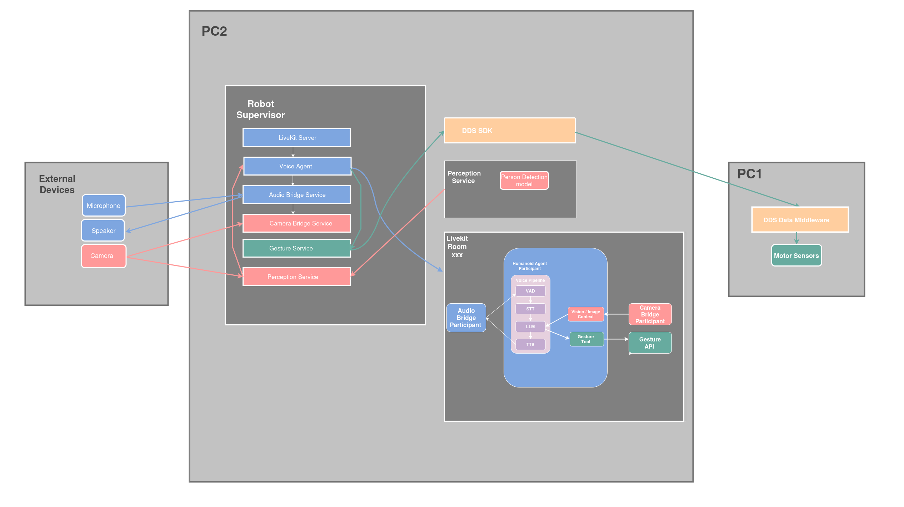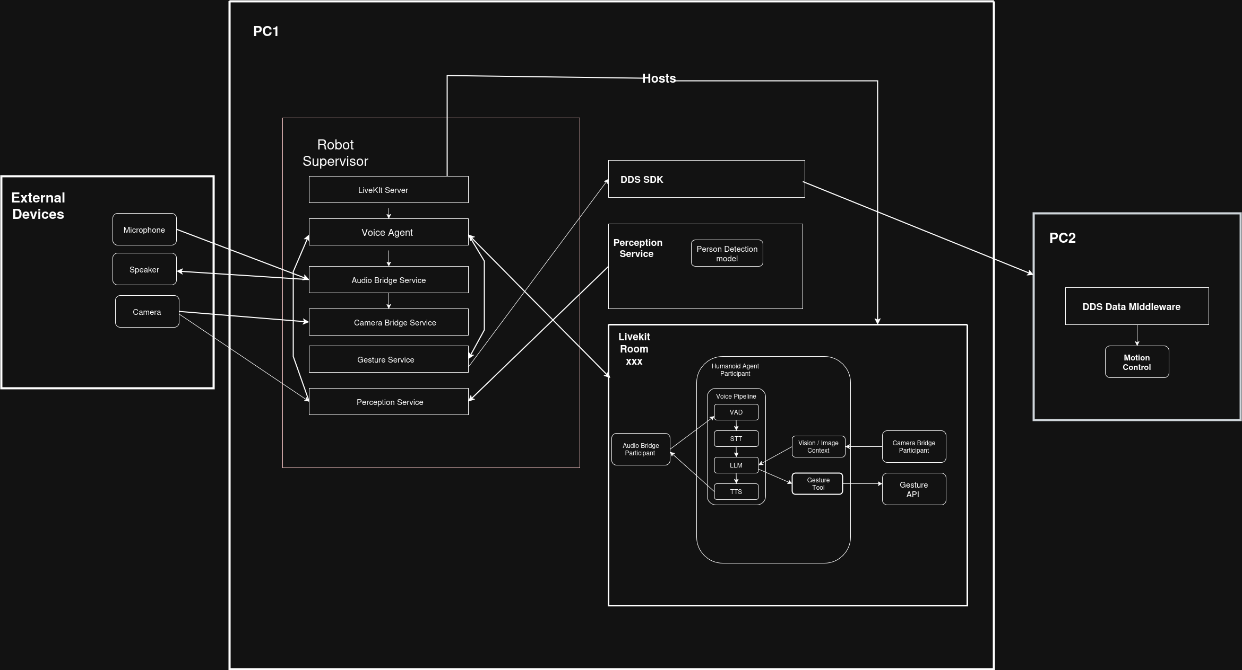
The diagram shows the high-level system architecture of the robot supervisor stack.

The HumanoidLivekit repo is used to run the Livekit agent on the Humanoid. A virtual environment must be set up as per this document’s development rules.
LiveKit is used because of numerous reasons:
- Real-time media transport (done properly)
  - Low latency audio, video and data channels,
  - WebRTC transport with production-grade tuning
  - Automatic connection handling, congestion control
  - Agent synchronization
- Clean integration point for VAD, STT, TTS, LLM
  - No need for own audio streaming
  - Buffering logic is handled between all the components
  - INTERRUPTIONS ARE HANDLED BY LIVEKIT
  - Continuous listening while speaking
- Data channels are properly provided
  - Streaming is implemented on all fronts, STT, TTS, LLM
  - Vision is polled correctly and can be provided with timestamps with language
- Observability
  - Sessions can be recorded for metrics, training and evaluation

The current project layout is as follows:
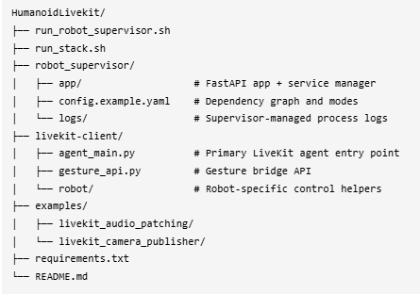

8.0 Repo setup on Humanoid
Work in progress – deployment will be automatized.

8.0.1 Running the stack
To run the stack, the interface needs to be accessed from robot_ip:8080 (in our case 10.242.17.39:8080. In order to start the stack, on the UI, the DISPATCH button can be pressed.
The other portion is that

8.1 Supervisor
The supervisor is a FastAPI service that manages the stack with dependency-aware ordering and a small web UI. The supervisor is ran on robot boot automatically as the robot starts.
USAGE: To access the Supervisor’s UI, open a browser on the robot’s IP when connected to either the same network, or it’s ethernet interface. For example, if the robot’s IP is 10.242.17.39, go to 10.242.17.39:8080 , as the exposed port is 8080.
By default, the supervisor reads robot_supervisor/config.example.yaml which defines:
Services: livekit, voice-agent, audio-bridge, camera-bridge, gesture-bridge, perception service
Dependencies: e.g. voice-agent depends on livekit, bridges depend on voice-agent
Modes: audio/camera bridges define multiple mode-specific commands (robot vs local for testing)

8.1.1 Running the Supervisor on boot
run_robot_supervisor.sh is designed for boot or cron:
- Creates/uses tmux session robot_supervisor
- Logs to /home/unitree/robot_supervisor_boot.log
- Activates .venv and launches Uvicorn with robot_supervisor.app.main:app
- Optionally answers the ROS env prompt if ROS_SELECTION is set
export ROBOT_SUPERVISOR_TOKEN="change-me"
export ROBOT_SUPERVISOR_CONFIG="$(pwd)/robot_supervisor/config.example.yaml"
export ROBOT_SUPERVISOR_PORT=8080
./run_robot_supervisor.sh

8.2 LiveKit Server
This service starts the LiveKit server so the rest of the stack can join a room. The supervisor runs it as a local process from the repo root (working_dir: ..) and waits ready_after_seconds: 1 before starting dependents.
We keep the --dev enabled even on the robot because this deployment is contained on a closed network with a single active room.

8.3 Voice Agent
This service runs the primary LiveKit agent process that handles speech, LLM responses, and robot behavior. The supervisor runs it as a local process from the repo root (working_dir: ..), waits ready_after_seconds: 2, and only starts it after livekit. Because the command starts with python, the supervisor will use the repo's .venv interpreter if present.
It can be read as a sequence of steps that prepare the agent, connect it to a LiveKit room, and keep it running as a real-time participant

8.3.1 Configuration
When the process starts, it first loads the .env file and pulls in all required environment variables through env_vars.py.
This includes Azure OpenAI configuration (endpoint, API key, API version) as well as optional settings for audio bridging and gesture control.
At this stage, the base system prompt is also defined. This prompt establishes the robot’s persona, tone, and behavioral rules that guide every interaction with the user.

8.3.2 Agent construction and behaviour
Next, a HumanoidAgent instance is created. This object encapsulates everything the agent is and can do.
As part of its setup, the agent:
- Registers a LiveKit byte stream handler on the images topic when it joins a room. This allows it to receive images in real time through LiveKit’s data channels.
- Caches the most recently received image and automatically attaches it to the next user turn, enabling seamless vision + language interaction.
- Controls visual context growth by limiting how many images can be attached using MAX_CONTEXT_IMAGES. Older images are trimmed from the context to keep prompts bounded (or image attachment can be disabled entirely).
- Exposes a trigger_gesture tool that calls an external gesture API over HTTP. This allows the LLM to directly trigger physical gestures on the G1 humanoid as part of its reasoning.
- Implements a placeholder camera_snapshot tool and the logic that decides when cached images should be injected into the conversation.
Together, this makes the agent multimodal-aware: it can hear, see, reason, and act without separate subsystems.

8.3.3 Prewarming speech components
Before the agent starts handling live traffic, the worker process prewarms its speech components.
Silero VAD and Truebar-related settings are initialized once per worker. This avoids cold-start latency when the first user starts speaking and ensures fast, responsive turn detection from the very beginning.

8.3.4 Starting the session
With everything prepared, the code creates and starts an AgentSession.
This is where all major components are connected into a single real-time loop:
- An Azure OpenAI LLM (gpt-4.1 deployment) is initialized using the configured Azure endpoint and credentials.
- Truebar is used for both speech-to-text and text-to-speech.
- Silero VAD is enabled to detect speech boundaries and interruptions.
- Room audio options are applied so the agent can continuously listen and speak inside the LiveKit room.
Turn-taking is explicitly tuned for natural conversation. The agent avoids preemptive generation, resumes correctly after false interruptions, and uses short endpointing and interrupt thresholds to allow quick, human-like back-and-forth.

8.3.5 Room and audio handling
The agent joins the LiveKit room with audio streams prepared in advance (pre_connect_audio=True), minimizing startup delay when speech begins.
The room is configured to remain open even if a participant disconnects, which makes the agent resilient to brief network issues.
If an audio bridge participant is configured (via AUDIO_BRIDGE_IDENTITY, defaulting to audio-streamer), the agent can route its audio input and output through that participant. This allows flexible audio pipelines without changing agent logic.

8.3.6 Session start and greeting
Once the session is fully running, the agent announces an initial greeting in Slovenian. This confirms that audio output, TTS, and room connectivity are all working as expected.
From this point onward, the agent continuously listens, processes speech and images, reasons via the LLM, and responds in real time.

8.3.7 Running as a livekit worker
Finally, the application is launched as a LiveKit worker using cli.run_app.
It runs in WorkerType.ROOM mode, with:
- an entrypoint function that creates and starts the agent session for each room, and
- a prewarm function that initializes shared resources ahead of time.

8.4 Audio Bridge
This service bridges audio between LiveKit and a physical or local audio device.
This service publishes a local microphone-style audio track and subscribes to remote audio for playback. It provides support for using different audio devices, like humanoid’s built-in microphone, built-in speakers etc.
The supervisor runs it as a local process from the repo root (working_dir: ..), waits ready_after_seconds: 3, starts it after voice-agent, and defaults to mode jabra. All modes use python, so the repo .venv is used when present.
Connects to a livekit server and joins a livekit room. Only one remote participant is rendered at a time, additional audio tracks are ignored until the active participant disconnects.

8.4.1 Audio Bridge Modes
There are some modes defined for this service, depending on which devices the agent should use.

8.4.1.1 External Audio
The mode external connects to a regular microphone and speaker (for example a laptop mic or an external USB mic) – it connects to the default audio input device.

8.4.1.2 Robot audio
The mode robot uses the robot_audio_bridge.py script, which does what is mentioned in chapter TODO. The robot’s microphone is used by subscribing to its UDP multicast and the Unitree SDK is used to do audio playback on the robot.

8.4.1.3 Jabra audio
Due to hardware acquisition limitations, the Jabra Speak2 55 was used to develop external audio MVP. Using device scanning, the script searches for a connected device whose name includes Jabra, speak2 or speak 2 to use it as the output and input device. This enables clearer and louder communication than using the external mode.

8.5 Camera Bridge
The Camera Bridge service is responsible for publishing camera images into the LiveKit room so the voice agent can perform vision-based reasoning.
Connects to LiveKit and publishes JPEG frames to the images topic.
It runs as a local process from the repository root (working_dir: ..) and is managed by the supervisor like the other services in the stack. The service depends on audio-bridge and is started only after audio and the voice agent are already running.
Camera support is optional. The livekit agent can operate fully without images. When enabled, camera frames are sent as byte streams and attached to LLM requests, which increases end-to-end response latency. For this reason, image cadence is intentionally kept low.
All camera frames are published to LiveKit on the byte stream topic images.

8.5.1 Camera Bridge Modes
The Camera Bridge supports multiple modes depending on the execution environment and camera hardware.

8.5.1.1 Robot mode
The mode robot represents the robot-mounted camera. Currently it is a placeholder, since the robot’s built-in camera in the Realsense D435i module is looking too low.

8.5.1.2 Local_linux mode
This mode local_linux uses OpenCV with the V4L2 backend for Linux USB cameras. On the robot, the default --camera-index is 6, as 0-5 are used by D435i.

8.6 Gesture Bridge
The Gesture Bridge service allows the voice agent to trigger physical gestures on the robot.
The Gesture Bridge depends on the voice-agent service and is started only after the agent is running. By default, it operates in robot mode and uses the repository’s Python virtual environment when available.
It exposes a small HTTP API that the agent can call whenever the LLM decides a gesture should be performed (for example, waving, pointing, or returning to a neutral pose). The service runs as a local process from the repository root (working_dir: ..) and is managed by the supervisor like the other stack components.

At a high level, the Gesture Bridge:
- Listens for HTTP requests from the voice agent.
- Translates gesture names into robot arm actions.
- Sends those actions to the robot using the Unitree SDK.
- Returns the robot arm to a neutral position after each gesture.
If the robot arm is unavailable or gestures are disabled, requests are safely ignored and reported as skipped.

8.7 Perception service
To introduce awareness of nearby people, we added Perception Service. Its purpose is to detect when a person approaches the robot with sufficient confidence and then automatically initiate communication.
When a person is detected, the robot should start the communication stack automatically – specifically the Voice Agent, Audio Bridge, and their dependencies. When the person leaves, these services should shut down to allow the next interaction.

8.7.1 Implementation
When the Perception Service is activated it runs YOLO tracking (yolo26x.pt) for real-time person detection. If a person appears in the camera view, their data is written to object_detection.lock file. In parallel, the robot supervisor continuously runs a vision engagement loop. Once this loop observes that a person is present, it starts the Voice Agent and Audio Bridge and keeps them running as long as at least one person remains in the scene. When no persons are detected anymore, the services are stopped and the system returns to the idle state.
For each detected person we store:
- track_id
- bounding box coordinates (bbox_xyxy)
- Confidence score
- last_seen_frame_index

8.7.1 Tracking details

The system uses VisionTracker class that runs YOLO with persist = true to maintain consistent IDs for people across frames. We keep an in-memory database of active tracks track_db keyed by track_id.
A person is considered no longer present if they are not observed for MAX_MISSING = 15 frames. At that point, we emit an “object_left” and event and remove the track from the database.

8.7.1 Current limitations
The perception service needs further improvement:
- Intent / engagement awareness is missing We need logic to confirm the person actually wants to interact, the person is close enough and in front of the robot (facing the robot)
- Re-identification across re-entry
If the same person leaves the scene and later re-enters, they are currently treated as a new person. We need a wat to recognize them as previously seen.

8.8 Data flow
In the image below, a detailed data flow can be observed between the user, audio hw, audio bridge, livekit server, voice agent, STT, LLM, TTS, and all of the implemented services: camera bridge, camera bridge, gesture bridge and the unitree controller.

9. Teleoperation
Teleoperation refers to the real-time remote control of a robot by a human operator. Instead of remote controlling the humanoid via Remote Controller or Mobile App, the robot mirrors the movements of a user through an external interface (VR HMD), enabling intuitive and direct physical control.
In our setup, XR-based teleoperation is used to control the Unitree G1’s arms and dexterous Inspire RH56-DFTP hands. A VR headset is used to track the operator’s arm movements, hand poses, and even individual finger articulation. These tracked positions are translated into robot joint commands, allowing the humanoid to replicate upper-body and finger motion in real time.
Full-body teleoperation is not yet implemented. For full-body tracking, additional hardware such as Kinect 2 VR (or similar full-body tracking systems) would be required.

9.1 Installation and setup
Teleoperation is based on the modified XR_Teleoperate repository.
The repository must be adjusted to work with our specific setup (as mentioned in the current status section. These modifications will be pushed to the repo.

General setup flow:
- Clone the xr_teleoperate repository and follow the installation guide within the repo’s README.
- Apply the required modifications for the G1 EDU configuration.
- Ensure network connectivity to:
  - PC2 (192.168.123.164)
  - Left hand (192.168.123.210)
  - Right hand (192.168.123.211)
- Start the teleoperation pipeline.
- Connect the VR headset and verify hand/finger tracking.
- Confirm joint response on the robot arms and DFTP hands.
For visualization and monitoring of camera streams during teleoperation, refer to TeleViewer (televuer).

